






BRIEFING PACK

CHIEF EXECUTIVE



CONTENTS

Welcome from our Chair of the Board of Trustees, John Baines 3
About The Fire Fighters Charity 4
Our Strategic Plan 5
Our Values and Behaviours 6
Chief Executive Role 7
Structure 11
Contract and Benefits 12
How to Apply 13

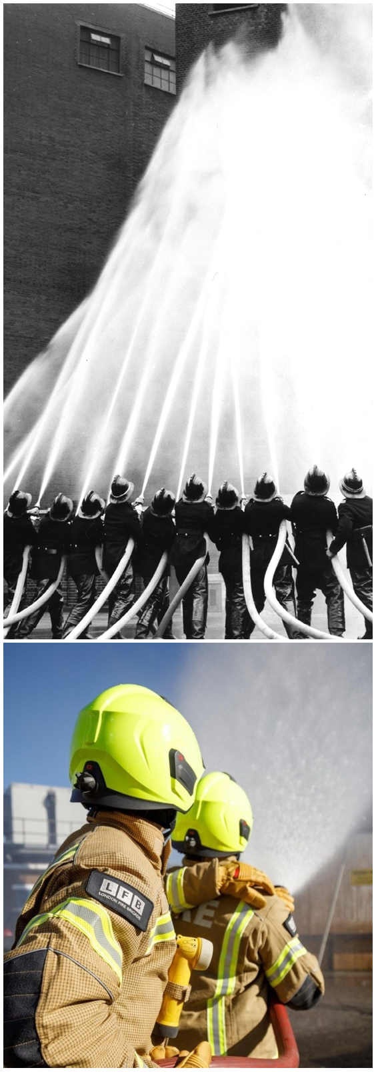

Welcome from our Chair of the Board of Trustees, John Baines

Thank you for your interest in the role of Chief Executive.

For more than 80 years, The Fire Fighters Charity has stood side-by-side with the UK’s fire services community, as a trusted source of support through tough times, an independent shoulder to lean on and an enabler for positive health and wellbeing change.

While our core ethos remains the same today as it was when we were founded in 1943 – to help fire and rescue service personnel and their families to overcome whatever challenges they may be facing – our organisation has evolved and diversified significantly over the decades.

Today we positively impact the lives of over 10,000 people a year, using innovative technologies to reach every corner of the UK. Through delivery of specialist residential programmes from three dedicated centres, and online consultations through our digital platforms, to operating within local communities and working hand-in-glove with fire and rescue services; we deliver with pride across a range of Health and Wellbeing activities. This solid base will provide the foundation to grow further the number of beneficiaries we support, through our next strategic plan and beyond.

Employing approximately 200 people, including a dedicated team of healthcare professionals, together with the support of a robust volunteer network across the UK, we continue to strive to break new ground. Positively impacting the lives of a growing number of beneficiaries and ensuring we can build a sustainable, long-term future for our Charity, through strengthening existing income generation channels and exploring new ones, is what drives us all forward.

Our new Chief Executive will be joining us at an exciting time, as our Charity embarks on a new strategic period. With the full support of a dedicated Board of Trustees, the successful applicant will lead The Fire Fighters Charity forward, ensuring we thrive in order to support all current and future beneficiaries to the very best of our ability.

We hope that having read through the information provided, you too will feel inspired to become part of our Charity.

John Baines
Chair of the Board of Trustees


About The Fire Fighters Charity
Since 1943, when the then Fire Service National Benevolent Fund helped bereaved families of firefighters killed during the Blitz, we’ve been side-by-side with the fire services community. We’ve evolved over the decades, but our ethos has remained the same: to ensure that we provide whatever support is needed for fire service personnel and their families, helping them through whatever life’s challenges may be.

It is important to recognise that the Fire Fighters Charity is a population specific charity – it is not ‘condition or issue specific’. Our roots as a benevolent organisation remain at the core of our values, of how we work and how we support our wide-ranging beneficiaries, who are united by their connection with a fire and rescue service.

We work closely with all the UK Fire and Rescue Services, providing high quality support, working in partnership to improve health and wellbeing, supporting physical, mental, and social health. Our support is available from the moment of joining the fire and rescue service throughout careers, into retirement and beyond. As key workers our fire services community are subject to many challenges and the Fire Fighters Charity provides a wide range of support to the workforce and their dependants.

Today, we make a difference to the lives of over 10,000 people a year, delivering preventative health and wellbeing advice and information – through a diverse range of online tools and in-person coaching – as well as physical and mental health support services for those with an identified need.

We also provide a diverse range of specialist programmes to support families and children; Living Well Groups, bringing people together on a regular basis and our befriending service, both of these support our retired population and help to tackle social isolation and loneliness; while our welfare team provides financial assistance when its required, as well as supporting individuals with essentials such as home adaptations.

We want to reach as far into the fire services community as we possibly can, so that all our eligible beneficiaries can benefit from the services that are available to them, including those within hard-to-reach groups such as on-call personnel, our retired community, and dependants.

By investing in innovative new digital technologies; the development of community-based initiatives; the sharing of health and wellbeing content and resources; close partnership working with fire and rescue services and organisations which share our goals; and campaigns to raise awareness, we are confident that we can positively, and sustainably, impact the lives of every member of the UK’s deserving fire family.

We are a strong organisation; with great opportunity to really make a difference to the health and wellbeing of our beneficiaries; We are resilient, and our resilience has seen us and will continue to see us through challenging periods.

For further information about The Fire Fighters Charity please visit our website www.firefighterscharity.org.uk



Our Strategic Plan
It is an exciting time for our Charity. Despite the challenges of working through a pandemic and the implications of the increased cost of living, we have successfully completed the first four years of our strategic plan for 2020-2025. Circumstance has enabled us to progress more quickly with our transformative change programme, and this year 2023-24, we are now closing our 2020-2025 plan one year early.

We have engaged with more of our beneficiaries and stakeholders, our services continue to be fit for purpose, evidence based and even more relevant in this changing world. We are currently working on the development of our next 3-year strategy to be signed off by our Board of Trustees to begin in April 2024.

Our current strategic plan has seen our Charity move forward into proactive support delivering health promotion, developing health literacy, and preventing poor well-being, actively engaging in digital health support, and developing our evidence base, whilst retaining our longstanding and highly valued face to face support, delivered in our 3 centres, in response to health needs and supporting recovery.

Our new plan builds on the successes achieved in the current and focuses on the following key themes to continue to build a healthy future for our Charity and for our beneficiaries.

- Improving health and wellbeing, reaching more of our beneficiaries, with a clear focus on prevention.
- Using our unique fire family knowledge and expertise.
- Increasing awareness of who we are and what we do through digitisation and business intelligence.
- Knowing that we are doing our best.
- Increase and diversify our revenue streams to ensure a sustainable budget to deliver on current and future service requirements.
Our income is solely from voluntary donations, and as with all charities, we have been challenged by both the impact of the pandemic and the cost of living and their impact on our ability to fundraise. Income challenges remain and there is more work to be done to develop and diversify our income portfolio, along with ensuring an acceptable return on investment for all our activities.

Our Values and Behaviours
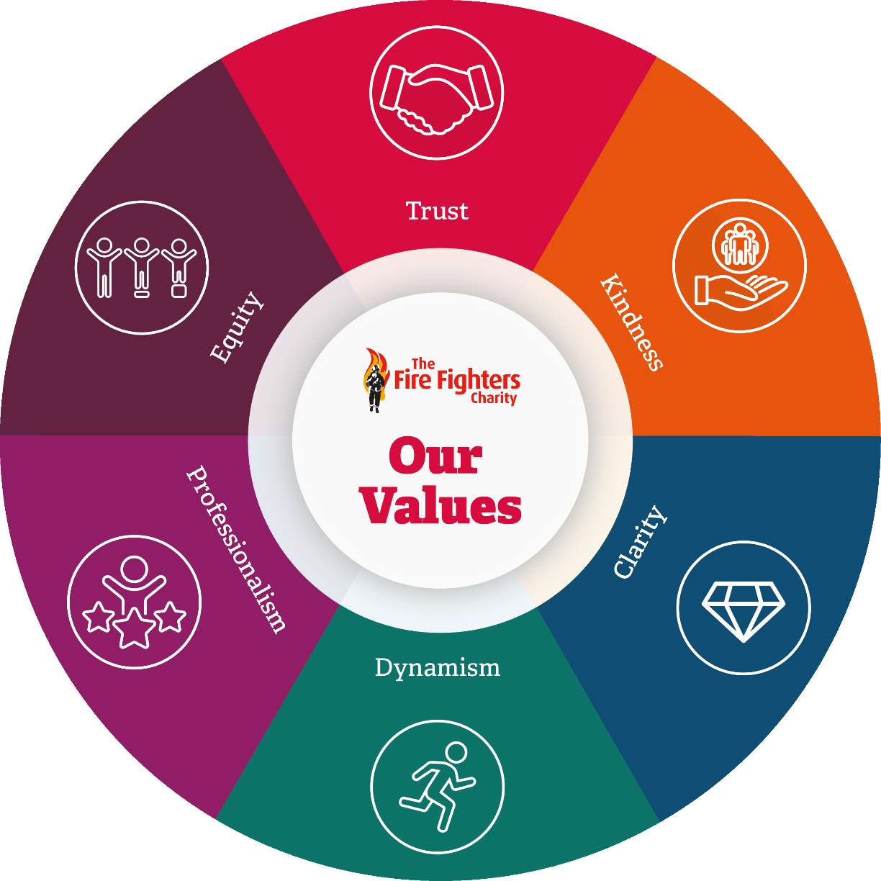

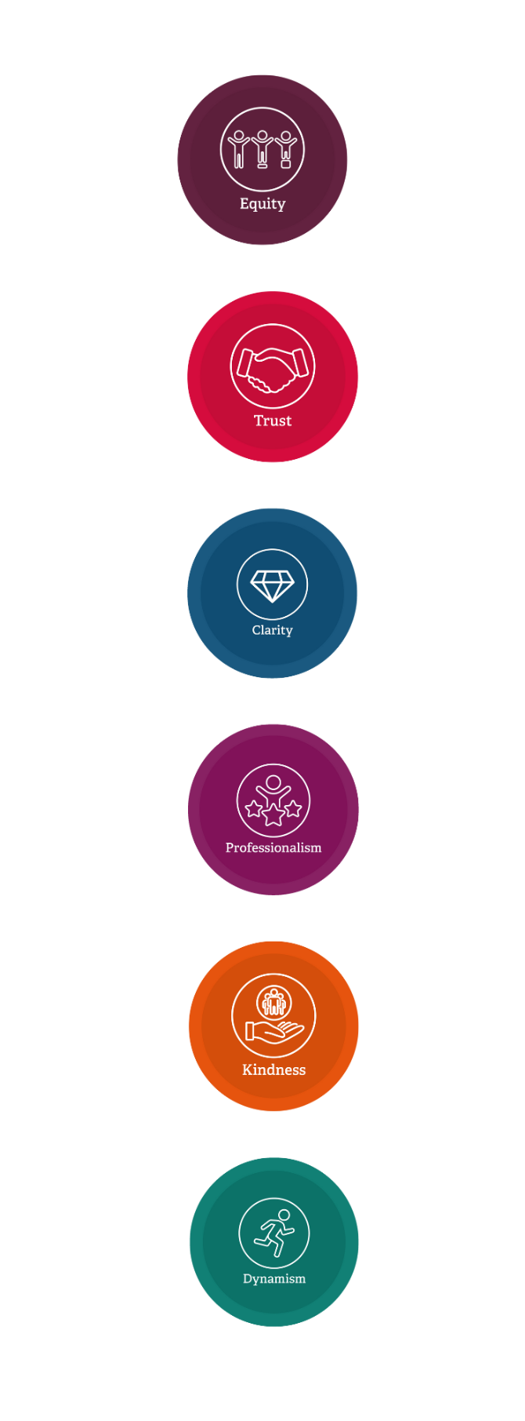
Equity
  - Fairness – we treat each other fairly and create a socially just organisation.
  - Inclusive – we create an environment where each individual can be their unique self.
  - Value – we value one another and ourselves.
.

Trust
  - Integrity – we are truthful and honest and extend trust to all.
  - Respect – we demonstrate respect for all and the contribution that we each make to the organisation.
  - Openness – we are approachable, genuine and authentic. We seek and encourage engagement and feedback.

Clarity
  - Purpose – we are united and clear in our vision and our purpose. We know where we fit and all work towards our common goals.
  - Communication – we communicate in a relevant and appropriate way to keep all our stakeholders informed and engaged. We actively listen and hear to give everyone a voice.
  - Shared Values – we are clear what is expected of us and how we deliver. We live and uphold our shared values and behaviours.

Professionalism
  - Proud – we take pride in who we are and everything we do.
  - Deliver – we strive for excellence in all things and at all levels, both in service to others and to ourselves.
  - Assured – we do the right thing, in the right way at the right time.

Kindness
  - Supportive – we support each other and all our stakeholders.
Our values reflect who we want to be and how we do things. At our Charity we all take a personal responsibility to remain credible, genuine and consistent to these values. These six values are our foundation and support our vision and ambition for the future.
  - Care – we create a positive environment for all.
  - Appreciative – we recognise the value of every individual.

Dynamism
  - Ambition – we motivate ourselves and each other to succeed and recognise success.
  - Future Orientated – we greet each day with purpose, founded on an understanding of our future direction.
  - Collaboration – we connect with teams and individuals, openly and frequently.

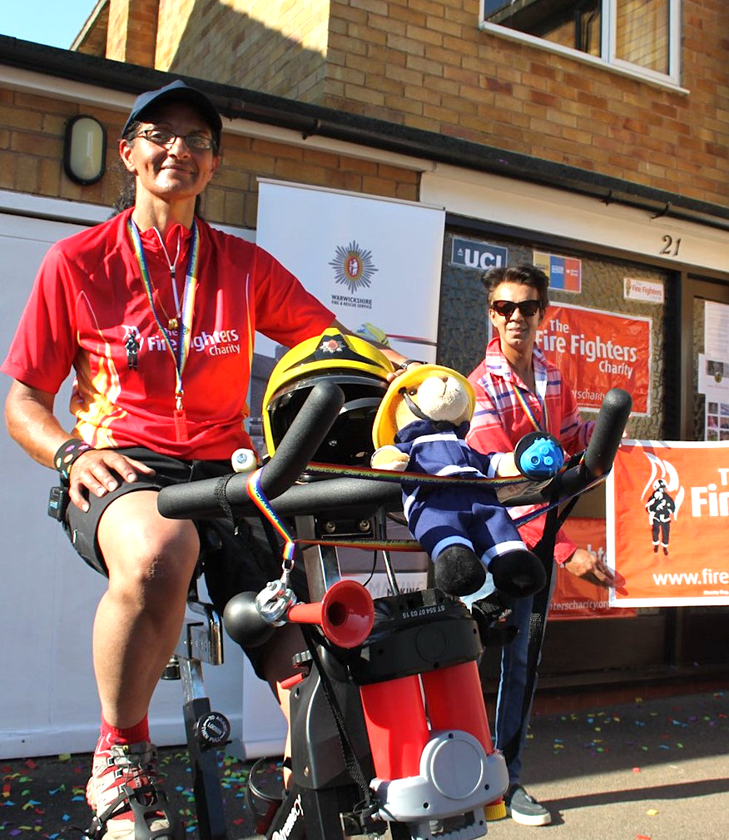
Chief Executive Role

Purpose

Your leadership, engagement, direction and innovation will be crucial to ensuring the Fire Fighters Charity delivers on our vision and values and provides lifelong support for members of the fire services community, empowering individuals to live happier and healthier lives.

In realising this vision, you will be responsible and accountable to the Board of Trustees, with whom you will work in partnership for the formulation, development and implementation of the strategies necessary to secure and successfully position our Charity for the future. In doing so you will create an environment aligned to our values to foster a culture of excellence.

Your, integrity, motivation and effective management will encourage high performance, development and a positive environment for the team, embedding a flexible and supportive culture of innovation, ensuring the right operational structures are in place to enable our Charity to thrive.

Your operational oversight will ensure the continuous development and high-quality delivery of health and wellbeing programmes through our specialist teams to meet current and future beneficiary needs, reaching progressively more beneficiaries, with a clear focus on developing the prevention agenda. In delivering our services you will ensure we build on these with best practice, develop our thought leadership and meet our compliance and regulatory requirements.

Your professional acumen will be demonstrated through astute judgement, critical decision making, problem solving and lateral thinking as you lead our employees and volunteers to make the best use of resources to increase and diversify our revenue streams to ensure financial sustainability to deliver on current and future service requirements.

You will evolve the use of technology to best serve our beneficiaries and build business intelligence to inform future practice and improve our ways of working.

You will bring a proven track record of effective stakeholder engagement, demonstrating this through effective communication and developing relationships with internal and external stakeholders.


Duties and Responsibilities

Leadership of our Charity, the Senior Leadership Team, Employees and Volunteers

Lead and inspire people at all levels of our Charity to ensure there is shared ownership of our vision, values and strategic aims.

Provide the framework within which the Trustees can participate in setting the strategic direction of our Charity with clarity for both internal and external audiences.

Create an environment which motivates the Senior Leadership Team to implement and articulate our Charity’s values and strategic direction.

Actively seek opportunities to engage employees and volunteers.

Set, direct and monitor the achievement of the outcomes required to deliver our Charity’s strategy within a framework of good governance and with sufficient and appropriate income.

Drive organisational programmes of change.

Ensure an effective organisational structure and the continuous improvement of our Charity’s policies, procedures and systems to best support our work.

Ensure that our Charity understands and is proactive in responding to the changing health and wellbeing needs of the fire services community.

Ensure that our Charity continues to be recognised as a key contributor in health and wellbeing in the emergency responder environment as a whole and in fire specifically.

As a Director of our Charity’s Trading Company (Fire Fighters Trading) to be responsible and accountable for its activities.

Service Delivery and Design

Ensure that systems, procedures and methodologies are in place to support innovation in service design and development to meet the needs of our beneficiaries.

Ensure operational leaders have the resources to deliver effective health and wellbeing interventions.

Performance Management

Provide General Management of our Charity; ensure frameworks are in place and provide assurance in all areas of work including risk, budget monitoring, audit etc.

Ensure effective target setting and performance improvement processes and procedures are in place and adhered to.

Finance and Income Generation


Work with the Board of Trustees to agree a long-term funding strategy to maximise income for our Charity from a variety of sources, to develop and sustain our services.

In collaboration with the Board of Trustees, ensure financial viability and accountability through accurate financial information and appropriate oversight.

Actively seek and drive opportunities to generate income.

Establish and monitor key indicators of our Charity’s financial health.

Work in collaboration with the Finance Director to produce an annual budget and cash flow analysis for our Charity.

Deliver an income strategy, resulting in robust financial resources to drive our Charity’s vision.

Promotion of our Charity

Protect and enhance the reputation of our Charity.

Seek opportunities to expand and promote awareness of our Charity’s work, regularly represent our Charity at high profile events, conferences, meetings and with personnel from the fire services community.

Work proactively with the National Fire Chiefs Council, Home Office, and other key bodies to promote the position of our Charity as ‘business critical’ to fire and rescue services.

Act as spokesperson, using the media appropriately to raise our Charity’s profile.

Governance

Provide regular reports to the Board of Trustees and attend all Board of Trustee meetings and sub-committee meetings as required.

Provide comprehensive information to support the Board of Trustees in its governance and decision-making role.

Co-ordinate the production of an annual report.

Ensure that our Charity complies with all legal and regulatory requirements.

Stakeholder Relationships

Build and maintain effective relationships with all stakeholders, including; Beneficiaries, Employees, Volunteers, Trustees, Company Members, Chief Fire Officers / Chief Executive Officers, Research Bodies, Corporate Partners, Regulatory Bodies, Government departments and Ministers.


Person Specification

Your ability to provide robust leadership and deliver results will be an essential element of the role. You will be an excellent communicator and ambassador and will have credibility and influence with our stakeholders and partners. You will be passionate about championing our Charity’s Vision and Values.

Evidence of the criteria below will be sought during the application and interview processes.

Essential

Effective leadership within an organisation and the ability to inspire and engage others to deliver organisational outcomes.

A passion for our Charity’s work, beneficiaries, and values.

Ability to lead and influence a positive organisational culture.

Evidence of leading significant organisational change to deliver sustainable performance improvement.

Ability to work with others to develop and implement organisational strategy effectively.

Evidence of leading and implementing service improvement.

Ability to work in partnership with a diverse range of internal and external stakeholders to successfully deliver outcomes.

Understanding of the social, political, and economic issues affecting our beneficiaries and the delivery of our Charity.

Clear financial understanding, and the ability to interpret organisational accounts to identify risks and opportunities.

Ability to effectively oversee significant capital and revenue budgets and people resources.

Relevant business acumen and commercial awareness.

Experience of effectively working with, advising, and influencing a Board, Governing Body, or similar, on complex organisational matters.

Evidence of maintaining good governance in a fair, ethical, and professional manner, in a challenging environment.

Evidence of continuous professional development relevant to the role.

Desirable

Demonstrable understanding of the current Health and Social Care environment.

A comprehensive understanding of the legal environment within which our Charity operates and of the voluntary sector.

Qualification

A leadership and management qualification at level 7 or equivalent demonstratable experience.

Structure
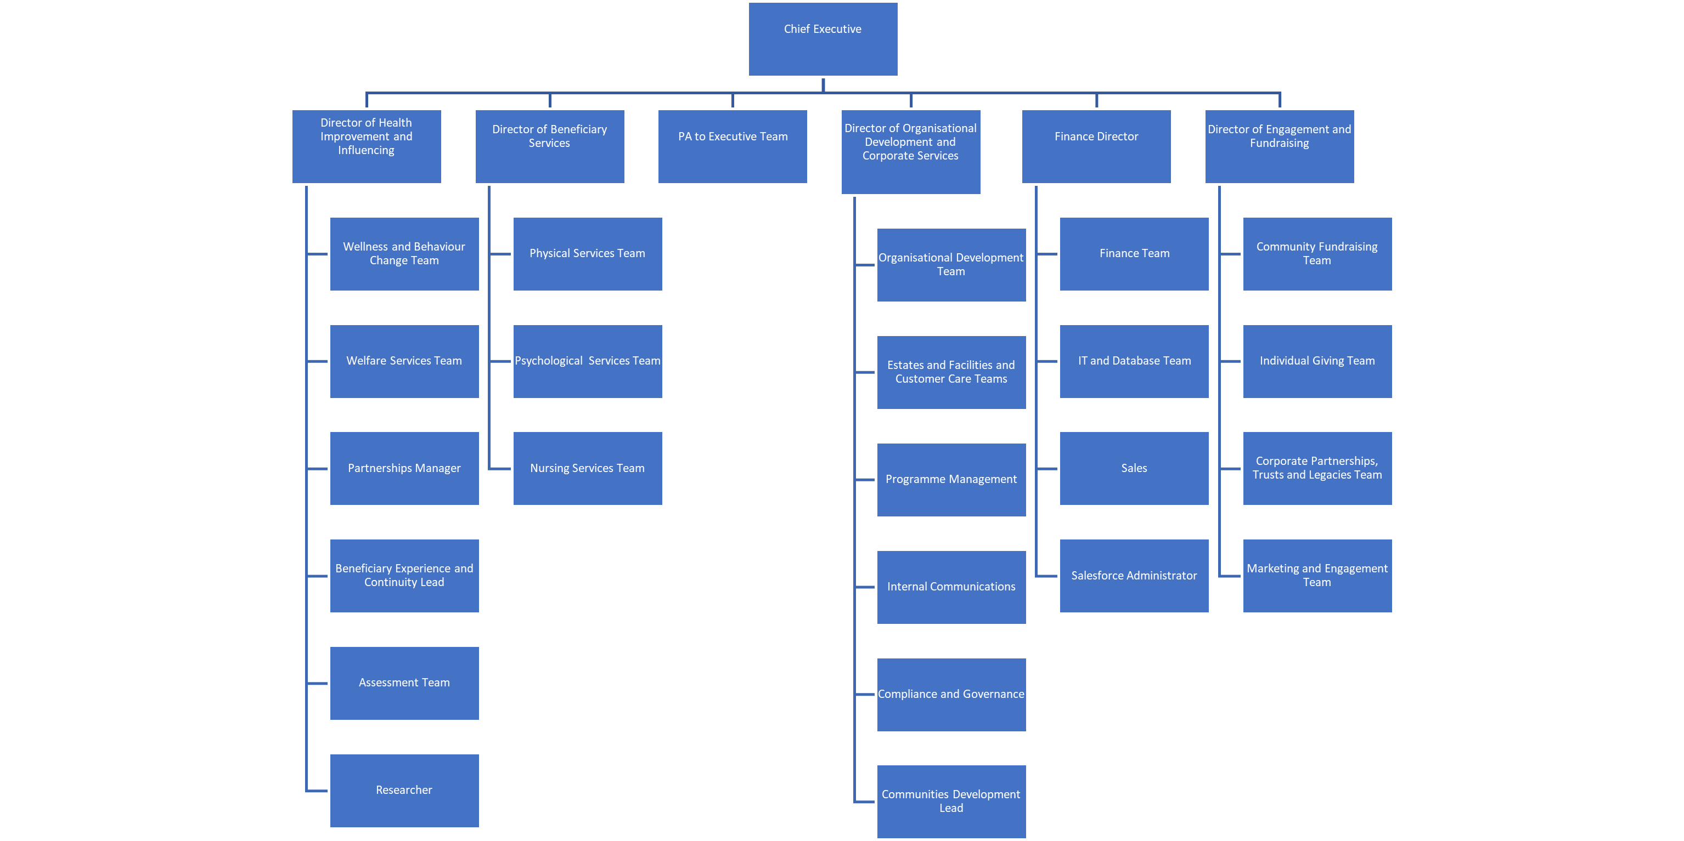


Contract and Benefits

Job Title: Chief Executive

Reports to: Chair of the Board of Trustees

Contract: Permanent, full time. Full time working hours are 37.5 hours a week. Due to the nature of the role some commitments may take place outside of the normal working day.

Pension: Our Charity operates a Group Personal Pension Scheme. Our Charity contributes 8% of salary. Personal contributions through a salary sacrifice arrangement can be requested.

Work Base: Homebased / Fire Fighters Charity work base / Hybrid. Frequent travel is required and some overnight stays.

Salary: £Competitive. Commensurate with chief executive leadership responsibilities.

Car Allowance: £7,000.

Annual Leave: 30 days plus bank holidays.

Life Assurance: 3 times basic salary, on death, payable to nominated individuals whilst employed by the Charity.

Employee Assistance Programme: A free 24hr confidential helpline which provides signposting, advice and guidance on a range of personal issues. If required telephone or face to face counselling is available.

My Benefits at Work: A portal that provides information and guidance on a range of financial and health and wellbeing matters.

Headspace: Access to the Headspace App which is a science-backed meditation and mindfulness tool which has hundreds of meditation and sleep exercises to support wellbeing.

Healthcare: A discounted health cash plan is available whereby employees can pay a monthly premium and then claim cash back for treatments.



How to Apply
If you wish to be considered for this role, please visit the campaign microsite (insert link) to upload your curriculum vitae, together with a covering statement which should address your motivation for wanting to be our new Chief Executive. Please include specific examples of what you have personally been responsible for and achieved and how that demonstrates you meet the requirements of the role and person specification. Please include your address and contact details.

To confidentially discuss the role in further detail please contact:

Laurence Wolahan, Hays Executive
Mobile: 07985 443 826
Email: Laurence.wolahan@hays.com
or
Katie Attrill, Hays Executive
Mobile: 07557 657 897
Email: Katie.attrill@hays.com

In order to assess the success of our Equal Opportunities in Employment Policy please complete our Recruitment Monitoring Form. All information will be treated in confidence and will not be seen by anyone directly involved in the appointment to these roles. To access the form, click here.

Our approach to inclusion is about creating an environment where all involved can be authentic in an inclusive environment. From cultivating a culture where everyone can be their unique self to deploying inclusive initiatives that support all, we’re committed to doing what it takes to build a socially just organisation.

Closing date for applications: Midnight, Sunday 28 January 2024

Interview date: Thursday 22 February 2024

Interview location: London Area

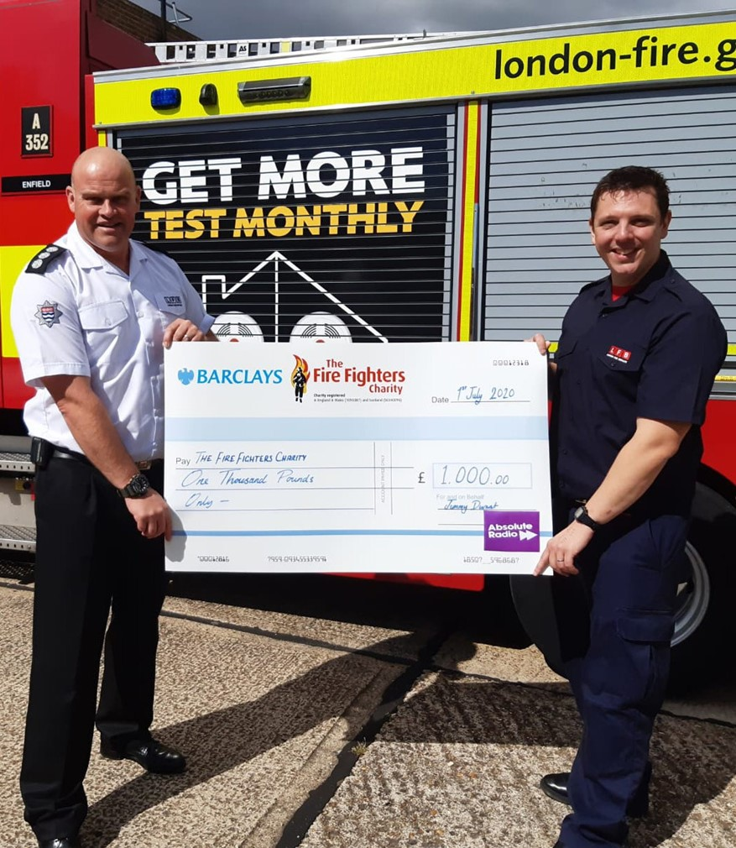

Data Protection Act 2022
Information provided by you as part of your application will be used in the recruitment process. Any data about you will be held securely with access restricted to those directly involved in dealing with your application and in the recruitment process. Once this process is completed the data relating to unsuccessful applicants will be stored for a maximum of one year and then confidentially destroyed.
If you are successful, your application form will be retained and form the basis of your personal record.
Information provided by you in the Recruitment Monitoring Form will be used to monitor The Fire Fighters Charity’s policy on equal opportunities in employment.
Please see our privacy policy for further information.

