**Job Description**

|  |  |  |
| --- | --- | --- |
| **Job title**: Head of Highway & Traffic Services | **Service Area/Division:** Streets & Environment | |
| **Directorate:** Sustainable Communities, Regeneration & Economic Recovery (SCRER) |  |  |
|  |  | |
| **Business Plan and Council priorities**  The [Mayor’s business plan: 2022 to 2026](https://www.croydon.gov.uk/mayors-business-plan-2022-2026) has five outcomes:   * The council balances its books, listens to residents and delivers good sustainable services. * Croydon is a place of opportunity for business, earning and learning. * Children and young people in Croydon have the chance to thrive, learn and fulfil their potential. * Croydon is a cleaner, safer and healthier place, a borough we’re proud to call home. * People can lead healthier and independent lives for longer. | | |
| **Croydon Council’s priorities**  We will live within our means, balance the books and provide value for money for our residents.  We will focus on tackling ingrained inequality and poverty in the borough. We will follow the evidence to tackle the underlying causes of inequality and hardship, like structural racism, environmental injustice and economic injustice.  We will focus on providing the best quality core service we can afford. First and foremost, providing social care services that keep our most vulnerable residents safe and healthy and keep our streets clean and safe.  To ensure we get full benefit from every pound we spend, other services will only be provided where they can be shown to have a direct benefit in keeping people safe and reducing demand. | | |
| **Croydon Council’s new ways of working**  We will practice sound financial management, being honest about what we’ve spent and what we can afford.  We will focus on what we, uniquely, can do as the local authority as the democratically elected leaders of our borough. This means we will focus on our core services, and a small number of evidence-based outcomes that deliver our priorities. But we will also continue to use our democratic mandate to convene our partners around a common purpose and to make a clear case for a better deal for Croydon.  We will aim to become a much more transparent, open and honest council.  We will involve residents in our decision making. But we will also need to be clear with residents about what we can do, and what we can’t. When we have to say no, we will do so with compassion and take the time to explain our decisions. | | |

**Job Purpose:**

The **Head of Highway & Traffic Services** will be the professional lead for all aspects of the service. Responsible for the strategic planning, co-ordination and delivery of a comprehensive range of Highway & Traffic services

As a member of the extended management team, the **Head of Highway & Traffic Services** will work collaboratively across their department and with other Heads of Service and directors to ensure the effective and efficient development and delivery of council services that support departmental and council objectives.

Ensure that our highways network is managed effectively, with a focus on sustainability and resilience, while delivering high-quality services that enhance the experience of residents and the travelling public.

To lead transformational change due to new legislation and deliver quality and value for money within the service, to work closely with the Director of Streets & Environment to limit the impact on front line services even when faced with a significant reduction in resources.

To ensure adherence to the Council policies, financial regulations and audit requirements. Ensuring that the service operates in line with relevant legislation, Health and Safety, Human Right Act, Freedom of Information Act, Data Protection Act and procurement requirements.

To act as Authority representative for the Joint Street Lighting & Electrical infrastructure PFI with Lewisham Council.

As required, the postholder will participate in corporate management activities that cross over service or departmental boundaries.

**Reports to:** Director of Streets & Environment

Croydon’s highway network is the single most valuable asset that the council owns. Without it, none of the council’s priorities, values and visions can be realised. Its 726 kilometres of carriageways, 1,235 kilometres of footways, 62 highway-maintained structures and bridges, 33,600 road gullies, 27,000 street furniture (traffic signs, pedestrian carriers, street name plates, grit bins, etc), 25,700 street lighting columns, etc and a total replacement value of around £1.74bn all need to be managed and maintained to ensure depreciation of the assets is kept to a minimum.

**Responsible for:** To be the professional lead for all aspects of the service, which includes:

* Highways Improvement, Highways Asset Management, Highways Development Control, Highways Term Maintenance Contract.
* Street Lighting and Electrical Infrastructure PFI (Croydon & Lewisham)
* Customer Service, Policy and Performance Management Teams
* Parking Controlled Parking Zones (CPZ) Design team
* Traffic Regulation Order Making Team
* Street Works and Permitting Team
* Network Coordination &Traffic Manager Duties
* Traffic Management & Road Safety Engineering, Design and Delivery Team
* To lead, manage and develop exceptional, high quality, high performing good value and efficient front-line operations and services in support of the council’s priorities and improved outcomes for residents and the borough.
* To lead and manage services, teams and employees of the Highway service working in collaboration within and on behalf of other council services, teams and with residents and community organisations, borough partners and supporting the council’s vision, values, behaviours. Including excellence in customer service, innovation and continuous improvement.
* To have responsibility for all operational, performance and improvement in relation to the following services:
* Responsible for the strategic and operational management and control of the highway services, ensuring that the service meets national and local priorities in a customer-focused and efficient way.
* To be lead advisor for the highway service delivery within the Directorate, including contract management, driving performance and ensure effective financial control and budget management
* Customer service ensuring that the Highway service in Croydon is managed in a proportionate and transparent manner, and that it is accessible and easily understood by the customer. To ensure an integrated, joined-up service provision across the varied parts of function and with partners.
* Responsible for the strategic and operational management and control of the highway service, ensuring that the service meets national and local priorities in a customer-focused and efficient way. To be lead advisor for the highway service delivery within the Service’s Directorate.
* To manage the development, operation, delivery and review of all highway services:
  + Responsible for ensuring that the specifications and costs meet the cash limits and that, within those parameters, they best meet the collective needs of service users.
  + Responsible for the management of all budgets associated with the Service, both expenditure and income.
* To manage the negotiations and operations of highways services, in particular Highway Contract and Street Lighting PFI contract as well as external support services and to ensure appropriate contracts are in place to deliver such services
* To ensure delivery of an effective, efficient and proactive customer focused service in accordance with the requirements of legislation, delegated powers, council standing orders and officer code of practice
* To be responsible for the development of service changes and programmes of work to address the constantly changing demands in relation to policies, law and practices, ensuring the service is kept abreast of relevant legislation and technical developments.

To make an active contribution to the extended senior leadership team for the department, taking responsibility for departmental and corporate priorities and initiatives.

**Strategy Development & Business Planning**

Working alongside the Director of Streets & Environment and senior management team, co-ordinate the development and delivery of evidenced based strategies, action plans and annual service/business plans for services and teams, the directorate and department incorporating key programmes, projects, targets etc. engaging managers, other services, councillors and staff in their development.

**Performance & Project Delivery**

Deliver better outcomes for residents and the borough and improved performance through the development and delivery of service improvement initiatives and projects and through effective management of performance including the introduction of quality management systems and effective use of management information and data.

Co-ordinate the development and delivery of key programmes and projects including business case development, developing funding and resourcing plans, effective project management and governance mechanisms and reporting though to successful implementation.

Ensure innovation and continuous development needed for the achievement of planned outcomes including financial and risk management, and effective resource planning.

**Residents, Customers & Digital Innovation**

Manage services and operations to be responsive to customers and residents including active resident and councillor engagement, ensuring that all systems and processes within service are designed effectively for residents and service users, have clear purpose and are cost effective.

Develop programmes and projects to support exemplary internal and external customer service and experience alongside developing clear customer service standards and service level agreements with an emphasis on digital services.

Use digital innovation to support the delivery of accessible and convenient services and improvements and efficiencies to services.

**Effective Management of Services, Teams and Employees**

Oversee the management, performance, training and engagement of teams and employees and effective communication to from and within services and embedding high-quality performance management including 1-1s, sickness absence, performance appraisals, objective setting, sickness absence management etc.

Advise senior managers and staff, Council and Members (as appropriate) when necessary on the work of the Highway service and give specialist / technical advice.

The post holder is responsible for a service budget of:

Highways income budget (revenue) £ 5.105m

Highways operational budget (revenue) £12.762m

Highways capital budget £12.573m

The post holders will deliver services and the associated savings programme and transformation projects within that budget envelope.

The post holder is responsible for 58 FTE’s in additional to a number of Service providers and associated contracts.

***Corporate Accountabilities (all Heads of Service)***

To take a “one Council” approach to deliver more effective outcomes and at all times avoid a siloed, single division or service area approach.

To actively seek out and learn from external good practice and bring those new ideas and ways of working into service development and delivery.

To contribute and lead as required as a project owner on the delivery and implementation of specific corporate projects as required.

To actively role model the council’s priorities and ways of working and the council’s leadership framework and values.

To lead, manage and develop staff teams and ensure compliance with the council’s performance management system and all HR policies and procedures

Be accountable for associated budget and have affordable plans in place to deliver the annual budget and Medium-Term Financial Plan.

Provide assurance that the services are compliant and performance monitoring is part of the corporate rhythm, and exceptions have robust action plans.

To operate within the governance, financial and legal frameworks of the Council at all times.

Ensure equalities is embedded into all aspects of professional and managerial roles, including service delivery and at all times carry out your duties with regard to the Council policy.

Ensure by robust management that the services and staff you are responsible for adhere to the Council’s Health and Safety Policy and operate within the safety management frameworks.

To ensure the effective management of data and security of information received and used within the division, to comply with the relevant legislation such as GDPR and the Freedom of Information Act, recognising that the council wishes to operate in the most open and transparent way.

Participate in cross organisational risk management and emergency planning activities as required

**Service Accountabilities:**

To work jointly with the Director of Streets & Environment other heads of service within the division to ensure the development and transformation of services that meet the new budget envelope in the Medium Term Financial Strategy is delivered.

**Financial planning and management**

Oversee the effective management of capital and revenue budgets including ensuring services operate robust monitoring, forecasting and corrective action supported by effective use of business intelligence, management information and data.

Ensure the identification and delivery of innovative savings and income generation proposals to reduce cost, improve value and minimise impact on front line services using a wide range of techniques including securing external grant funding.

Develop a commercial approach to service delivery including development of business cases and the identification of new income streams, identification of innovative and alternative delivery models and the procurement of services.

Managing budgets, using sound financial management and application of the Council’s financial regulations to ensure spending is within budget and providing value for money and identifying any potential for efficiency savings.

Instil a culture of customer service and ‘can do’ attitude across teams

To take decisions on strategic issues involving legal, technical, social, economic and cultural matters concerning parking management policy & procedures.

The list of duties in the role profile should not be regarded as exclusive or exhaustive. There will be other duties and requirements associated with your job and, in addition, as a term of your employment you may be required to undertake various other duties as may reasonably be required.

Your duties will be as set out in the above role profile but please note that the Council reserves the right to update your role profile, from time to time, to reflect changes in, or to, your job.

You will be consulted about any proposed changes.

**Key Stakeholder Relationships:**

Internal:

Members; Chief Officers; Directors; Heads of Service; other teams and senior departmental colleagues across the whole council; trade unions.

External:

National and London wide bodies in the public, private and voluntary sectors, Government departments and agencies (e.g. GLA, Design for London, Government office for London, TFL, Department for Transport, Road Hauliers Associations, Audit Commission, Association, Regional bodies, Partner organisations, contractors and suppliers, Members of the public and community groups, Other Local Authorities, Professional organisations and consultancies

Be an active member of the London Technical Advisors Group (LoTAG) surrounding highway functions to keep abreast of the latest technical developments in the service areas.

**Political Restrictions:**

This post is politically restricted. Will only apply to HOS whose duties also involve giving advice to committees, sub-committees or to the Cabinet or speak on behalf of the Council to journalists e.g. Head of Scrutiny, Head of Communications, deputy monitoring and S151 officers.

**Delegated Authority:**

The post holder will be required, on occasion to deputise for the Director of Streets & Environment and will represent the Council in a wide range of external multi-agency forums including those with central government and affiliated organisations.

**Statutory Responsibilities:**

As part of the senior management of the organisation, deliver the council’s services in accordance with our vision and strategies and within the resources allocated.

Support the Council’s Cabinet and elected Members by:

* providing advice and guidance.
* ensuring the effective implementation of its decisions
* taking delegated decisions within the Council’s
* financial Regulations; and
* enabling the effective scrutiny of services and decisions.
* Discharge the statutory duties within the department and advise Members and the corporate management team in relation to policies, priorities and strategies related to these matters.

***Delivery of front-line and operational teams***

As set out in the council’s scheme of management and scheme of delegation the post has delegated powers and authority in line with the responsibilities detailed above.

Exercise responsibility for the delivery of statutory obligations and act and operate to the highest standards in accordance with the council’s plans, financial regulations and Standing Orders, ensuring the provision of an exemplary service to the council and its customers

Take responsibility for leading and managing and all aspects of highway operational delivery, key project delivery and service improvement programmes to support the council’s key commitments and targets.

Working alongside the Head of Service, report on and advise the council and Director of Streets & Environment on new developments, industry innovation, good operating practice and local, regional & national policy and the implications for the council in relation to network management & coordination, business processing, income recovery etc.

To manage and direct operational teams to ensure the effective delivery and integration of work relating to a wide range of statutory and other functions which are designed to ensure that the Council’s objectives, the Government’s and associated agencies’ targets and the community’s aspirations are implemented.

**Key Outcomes & Deliverables:**

* To ensure that the Highways Asset Management Plan accurately reflects the aspirations of the Council
* To ensure the duties placed upon the Council by the Traffic Management Act are discharged effectively and that road space in the Borough is managed appropriately.
* To manage all contracts in a manner that delivers the best for Croydon
* To work with other teams to create a place where people and businesses want to be
* To create a place that communities are proud of and want to look after as their neighbourhood.
* To build a place that is easy and safe for all to get to and move around in and create a place where people feel safe and are safe.
* To be at the forefront of innovation
* To be innovative and enterprising in using available resources to change lives for the better using the HAMP as a vehicle for change.
* Lead the Directorate’s delivery model for the commissioning arrangements for highway services.
* To effectively manage utility and contractor presence on the network
* To work with other departments to deliver the broader goals and ambitions for Croydon where the public highway is seen as a catalyst for change.
* Take responsibility for cross-cutting initiatives and community plans, including additional portfolios as allocated by more senior management.

**Other Considerations:**

You may, from time to time, be required to work outside of regular office hours including weekends and evenings to attend meetings and community events.

The postholder is required to observe and fulfill the seven principles of public life (also known as the Nolan Principles).

|  |
| --- |
| * 1. **Selflessness**   Holders of public office should act solely in terms of the public interest.  **1.2 Integrity**  Holders of public office must avoid placing themselves under any obligation to people or organisations that might try inappropriately to influence them in their work. They should not act or take decisions in order to gain financial or other material benefits for themselves, their family, or their friends. They must declare and resolve any interests and relationships.  **1.3 Objectivity**  Holders of public office must act and take decisions impartially, fairly and on merit, using the best evidence and without discrimination or bias.  **1.4 Accountability**  Holders of public office are accountable to the public for their decisions and actions and must submit themselves to the scrutiny necessary to ensure this.  **1.5 Openness**  Holders of public office should act and take decisions in an open and transparent manner. Information should not be withheld from the public unless there are clear and lawful reasons for so doing.  **1.6 Honesty**  Holders of public office should be truthful.  **1.7 Leadership**  Holders of public office should exhibit these principles in their own behaviour. They should actively promote and robustly support the principles and be willing to challenge poor behaviour wherever it occurs. |

**Person Specification**

**Specific Minimum Qualifications and Expertise**

**Qualifications:**

It is essential to be educated to degree level or equivalent and a member of a professional body (e.g. Chartered Institute of Highways & Transportation) is desirable. Engineering Chartership is desirable

**Experience:**

* Experience of demonstrating strong and visible leadership and management skills and the ability to lead, motivate and enthuse front-line and technical teams and employees whilst creating a culture in support of organisational vision, values and behaviours with an emphasis on excellent employee and Trade Union relations.
* Knowledge and experience of operational business and financial planning and the delivery of high performing operational services and successful programmes and projects (including effective governance, risk management) to deliver better outcomes.
* Knowledge of and ability to lead and manage the delivery of improved organisational culture and the delivery of equality, diversity and fairness into all aspects of service provision and programmes.
* Proven ability to lead a strategic team at a similar level through customer services and leadership capability
* A successful track record and background of consistent achievement at senior management level within the parking sector, in a local authority or large complex organisation.
* Experience of establishing and implementing business planning processes and performance management systems to ensure appropriate and cost-effective service delivery.
* Demonstrable excellence in team management and service delivery in relation to the provision of customer orientated services that achieve successful outcomes.
* Experience and track record of developing effective internal working relationships and actively creating and working within external partnerships including commercial organisations and professional bodies to deliver improved results.
* They will provide a co-ordinated approach to the use of the highway, and the network co-ordination role, and will develop and implement programmes that align with the Council's strategic vision to reduce traffic, improve road safety and air quality, increase active travel (cycling & walking), aid accessibility and enhance road-based public transport

**Knowledge and Skills:**

* Technical knowledge (including transport & highway legislation) of and expertise in managing high performing, high quality, efficient Highway Services.
* Track record of successfully operating as a senior leader and manager at senior operations / service head level in a large, complex and comparable operational setting (local authority, public sector organisation, private sector enforcement or equivalent).
* Knowledge and experience to drive the continuous improvement of operational services by embedding the analysis and use of evidence, benchmarking data, performance (HR, financial, operational) data and operational metrics and the use of quality management systems.
* Proven experience and exemplary and financial management skills and the knowledge and ability to develop and deliver innovative savings and income generation opportunities using a breadth of techniques and exploit grant funding opportunities.
* Knowledge and experience of developing resident and community engagement and involvement in services projects and plans, including behaviour change programmes and communication campaigns.
* Knowledge of applying commercial approaches and principles to service and project delivery including innovative, alternative delivery models, development of financial business cases and the identification of new income streams.
* Track record of working in support of departmental and corporate initiatives and projects with peers, senior officers.
* Knowledge of service and operational transformation change and improvements and the track record of delivering successful transformation projects.
* Experience of and a track record in working in political environment and demonstrating political awareness with the ability to create effective working relationships with Cabinet Members, ward councillors, MPs, etc. including the ability to provide objective, complex and technical advice and support.
* Knowledge and experience of applying digital and technical innovation and the provision of exemplary customer service.
* Ability to represent the council acting as an ambassador with a wide range of stakeholders including community and borough organisations and with external professional and public sector organisations.
* An up-to-date knowledge of relevant national, regional and local policy in order to develop strategies and plans.
* High level of communication skills to persuade and engage audiences and form positive relationships at all levels (internally and externally).
* Ability to work in a collaborative way to transform service delivery including the ability to manage internal departmental relationships
* An acute understanding and knowledge of financial and budget management including probity, commissioning, delegations, forecasting and management accounts.
* Evidence of being a strong corporate player who will lead, motivate and inspire their teams and build a high performing culture.
* Ability to work effectively across a range of service disciplines and with a range of people.
* Commitment to the Council's core value and objectives

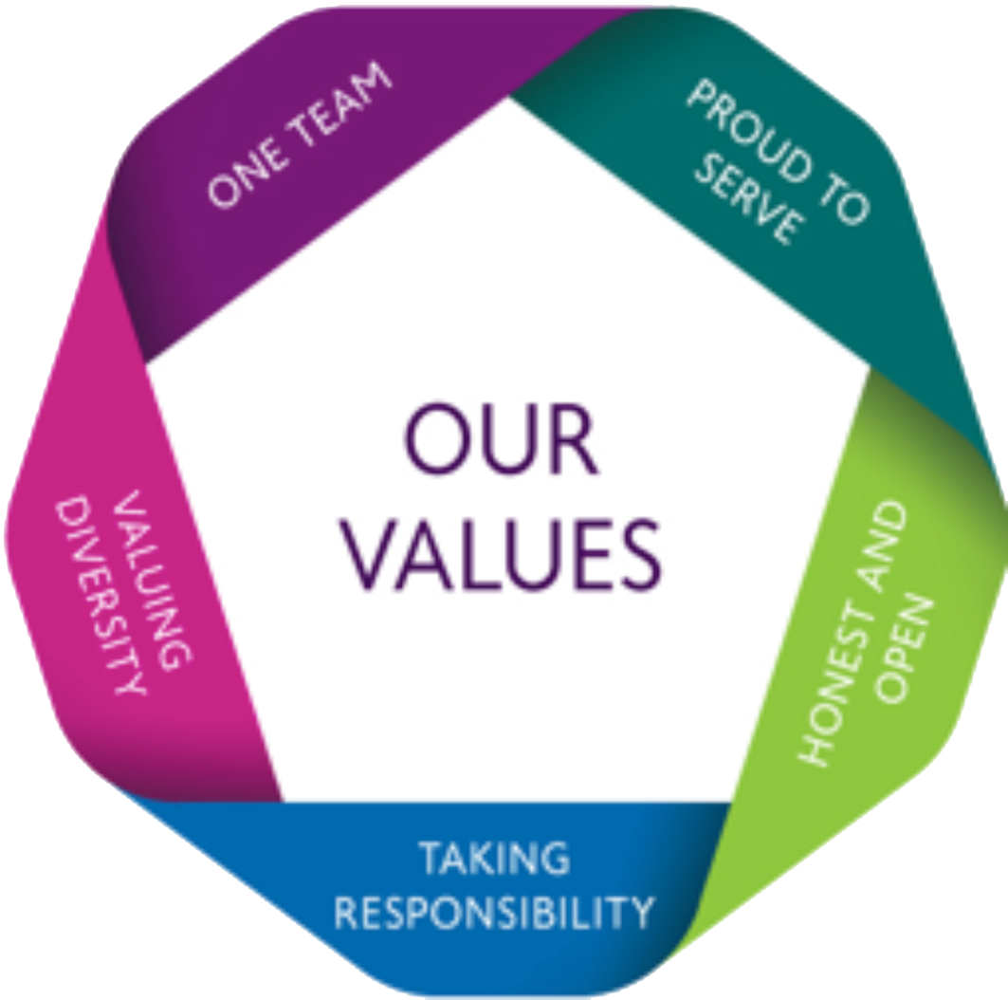**Corporate Values**

Our values are the base of every job role within Croydon – our values are fundamental in everything we do as a Local Authority. You are required to demonstrate a commitment to our corporate values and this will be assessed using the criteria below:

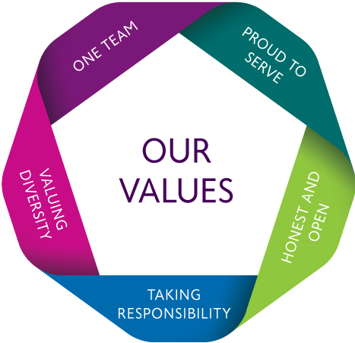**One Team:** To cross boundaries to work together towards shared goals with colleagues, partners and communities.

|  |
| --- |
| * You are strategically innovative in your approach to building and maintaining partnerships and you and your teams act in a joint enterprise with them. You use your contacts and colleagues to bring teams together.   **Proud to Serve:** We strive to always do our best for the community, getting the most from limited resources and using taxpayers’ money wisely |

* You are proud to be part of the wider Croydon and the contribution you and your teams make to it. You make a difference to people’s lives through engagement, and you strive to get the best possible value for money for customers.

**Honest and Open:** We work hard to build trust by treating everyone with honesty and integrity

* You think through who needs to understand what during communication; and take care to communicate detail clearly. You take people’s views into account continuously. You trust people, colleagues and staff, to do their best and deal with any issues positively.

**Taking Responsibility:** We encourage and support each other to take responsibility and show what we can do, learning together and recognising each other’s contributions

* You are clear where formal accountability lies and where we can all take responsibility for results. You praise your colleagues for their efforts and ideas and thank them for their contributions.

**Valuing Diversity:** We make the most of the many perspectives that make Croydon distinctive

* You treat all staff and customers with equal value and respect. In everything you do, you make good use of the wide variety of background, skills and perspective your teams, the Council and the community demonstrate.