
PRE-EMPLOYMENT
HEALTH DECLARATION FORM

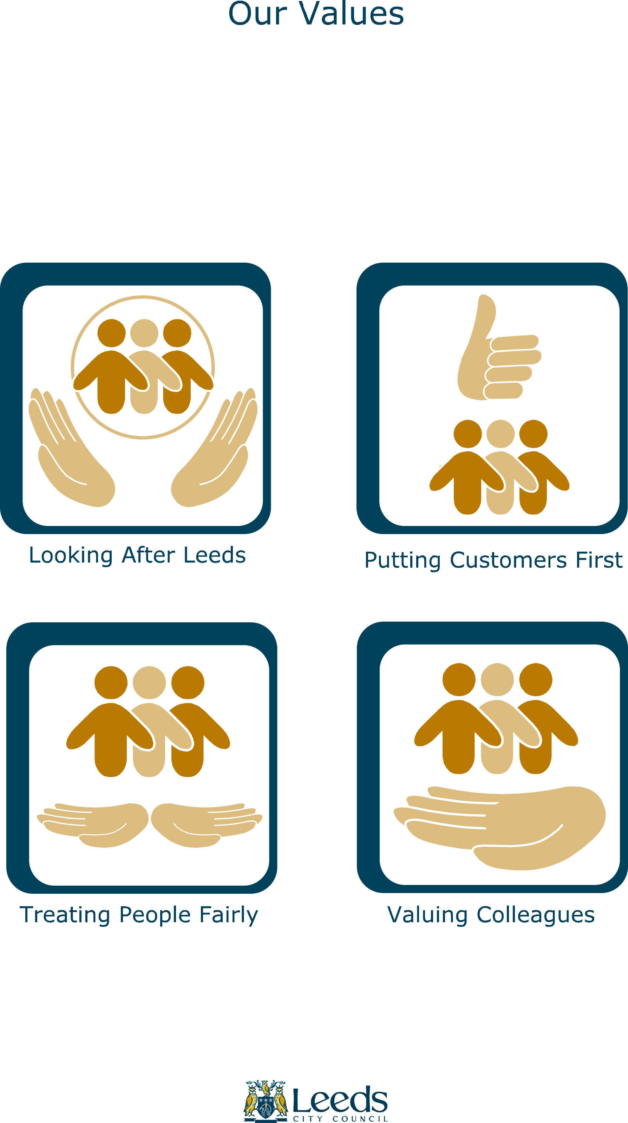

Leeds City Council recognises that the safety, well-being and attendance of its employees is an integral part of achieving these four core values. As part of this commitment every prospective employee is required to complete a health declaration prior to taking up employment.

Guidance

Leeds City Council is an equal opportunities employer and declaration of a physical or mental health problem should not impair your chances of employment, unless it is clear it will cause you, your colleagues or clients, health, safety or attendance problems. Every reasonable adjustment will be made to accommodate all successful candidates.

The information you supply will not be used to ‘select’ candidates. It will only be considered once a ‘preferred’ candidate has been selected - as part of the appointment process.

This information will be treated in the strictest confidence and processed in accordance with the Data Protection Act.

You will be asked to place your completed form in a self-addressed envelope. If you are not successful this information will be destroyed or, if you request, returned to you unopened by post.

If the interview panel designate you as a ‘preferred’ candidate your completed form will be assessed in the first instance by either:

- The Council’s Occupational Health Provider, for more hazardous roles (Part A); or
- by a Human Resources Adviser, for less hazardous roles (Part B).

In either case, if more detailed information is required, medically qualified Occupational Health Nurses/Physicians may contact you and/or arrange a meeting. Occupational Health will treat all information in accordance with the Access to Medical Reports Act.

Completed forms for applicants subsequently recruited into the post will be kept on a file, either within Human Resources or Occupational Health. The information will only be used for matters related to your recruitment process and will be stored in a secure and confidential location.

If you require any further information on how we handle this information please do not hesitate to contact Julie Falkiner (0113 22 43213).

Please ensure that you have read the declaration BEFORE completing and signing the form.

Section1

Job Risk Analysis

Recruiting Employer: Leeds City Council

Department and Section: City Development / Asset Management & Regeneration

Post / Job Title: Senior Land and Property Officer

Description of main activities the applicant would be required to undertake:
Negotiating acquisitions and disposals, undertaking valuation and report writing, working from the office and home, and undertaking site inspections.
Hours / work pattern: 37 a week.

If the work contains any of these elements it is defined as a PART A ROLE

Work element
Work at heights (eg over 2m). NO
Work in excessively noisy environments. NO
Work in unusual environmental conditions, eg confined spaces (where the air
does not flow free and fresh or where there may be a build-up of gases, vapours
or fumes or the need for the use of breathing apparatus). NO
Use of tools and equipment associated with hand-arm or whole-body vibration. NO
Driving Leeds City Council Vehicles. NO
Transporting others (ie only those driving HGVs over 7.5 tonnes, PCVs,
minibuses (eg requiring MIDAS qualification / DVLA Gp 2) and anyone
transporting, as part of their normal duties, more than 3 persons. NO
Contact with hazardous substances identified as requiring regular health
surveillance under COSHH, nb this includes infectious agents eg from bodily
fluids, or zoonoses. NO
Prolonged or frequent exposure to machine generated wood dust, or other
heavy or excessive concentrations of mineral dust. NO
Work with lead or lead-based products. NO
Work with, or regularly in, environments where there is likely to be, asbestos
containing materials. NO
Where the role requires an employee to be immunized. NO
Fieldwork or work in extreme conditions eg involving excessive heat, cold,
frequently walking long distances over rough terrain in all weather conditions. NO
Any other occupational hazards/comments relevant to this post (state). NO

All other roles are defined as Part B. Please indicate if the work involves any of these elements.

Work element
Face to face contact with the public / service users. YES
Working in isolation / lone working. YES
Work with electrical wiring. NO
Work where there may be occupational exposure to bodily fluids (all reasonable
control measures will have been identified and implemented). NB if the risk assessment identifies that immunization is required, this should be classed as a
Part A role. NO
Work that may bring the employee into contact with rodents or other animals or livestock. NB if the risk assessment identifies that immunisation is required, this
should be classed as a Part A role. NO
Manual handling / moving and handling (ie other than routine office lifting
and carrying). NO
Working with vulnerable service users. NO
Work with repetitive movements or forced posture. NO
Work as a regular display screen user. YES
Work involves the preparation or handling of unwrapped foods, to be consumed
without further cooking eg sandwich preparation. NO
General office-based activities. YES
Driving own vehicle on Council business. YES
Any other occupational hazards / comments relevant to this post (state): NO

NB Appropriate control measures for these identified hazards will have been identified and implemented.

This role has been classified as a PART B ROLE

